



**Executive Summary: PPMO Ecosystem Application**

**Version 1.1**

**Epic**

COP “ community of practise” subscribers will have access to the following clips that provide data, tools and tactic’s, personal story experiences. Empowering them to deal with similar situations/risks.

| **REVISION HISTORY** | | | |
| --- | --- | --- | --- |
| **Doc Version** | **Date** | **Author** | **Description of Revision** |
| 1.0 | 10 th Jan 2022 | CIS | Estimation |
| 1.1 | 19th Jan 2022 | CIS | Milestones/Sprints |

| **Table of Content** |
| --- |

1. Company Introduction

2. Project Briefing

3. Assumptions

4. Resources

5. Target Platform Baseline

6. Platform Compatibility Baseline

7. Scope of Work

7.1 Development

7.2 UI Designing

8. Resource

9. Technology Stack Baseline

10. Risk

11. Acceptance Criteria

12. Out Of Scope

13. Prerequisite

14. Staging and Beta Environment

15. Special Hardware & Software requirements

16. Reporting Tools

17. Project Monitoring

18. Service after Deployment

19. Terms & Policies

| **1. Company Introduction** |
| --- |

Established in 2003, Cyber Infrastructure Pvt. Ltd. (CIS) is a leading IT and consulting company in Central India. Since 2003, CIS has been providing highly optimized technology solutions and services for SMEs and large scale enterprises across the world. Our global delivery standards have received accolades in the form of prestigious quality certifications of **CMMI Level 3** and **ISO 9001:2015**.

CIS has worked with 2100+ clients in more than 100 countries. Our expertise and experience ranges across a wide range of industry domains like education, finance, travel and hospitality, retail and e-commerce, manufacturing, gaming, media and entertainment, logistics, hi-tech, telecommunication, health care, and many more. CIS offers comprehensive IT services such as custom application development, mobile application development, creative web design, Microsoft solutions, SAP solutions, open source development, Java development, Oracle development, big data solutions, digital experience solutions, CAD/CAM architectural services, testing automation, infrastructure automation and cloud, digital marketing, ITeS, etc.

**Our Partner**



**Key Heighlights Of CIS**

**Our Core Values**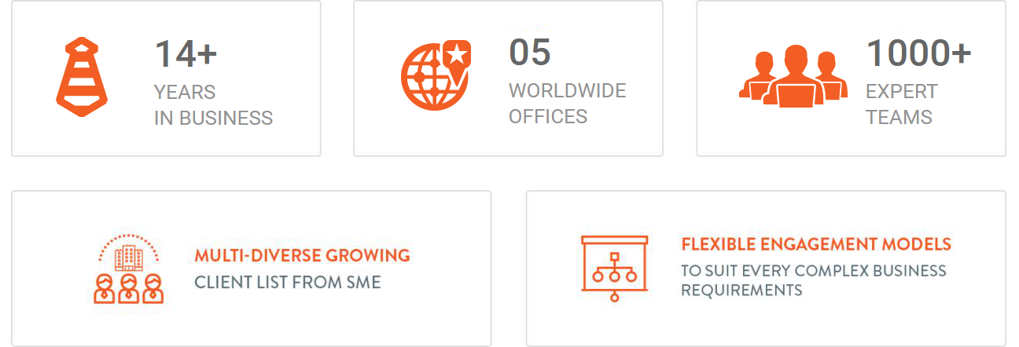



| **2. PROJECT BRIEFING** |
| --- |

**Epic**

COP “ community of practise” subscribers will have access to the following clips that provide data, tools and tactic’s, personal story experiences. Empowering them to deal with similar situations/risks.

**User Stories**

As COP “community of practise” subscriber on this PPMO ecosystem mobile APP. I should be able to access clips, information, tools and technics, experimental learning. That will enable me, my loved ones to better navigate this life changing environment.

As COP I am able to use what is shared to protect my loved ones and reduce/limit unnecessary related navigation/engagement costs.

1-As a COP I should be able to share this mobile app with my network/friends and family.

2-After downloading mobile app, everyone should get access to the “WHY Subscribe”. And be able to subscribe when convinced.

3-As a subscribed user I should get access to the main topic clips as well as access to give feedback and comment.

4-As a subscribed member I should get notice and access of new Marketing clips and new main subject clip updated.

Please remember the aim is to create a MVP at the lowest cost but drive subscription sales. Those revenues will then be used to build other functionality and features incrementally as we get feedback from end user.

Regards

Zim

Website : <https://ppmoecosystem.com/>

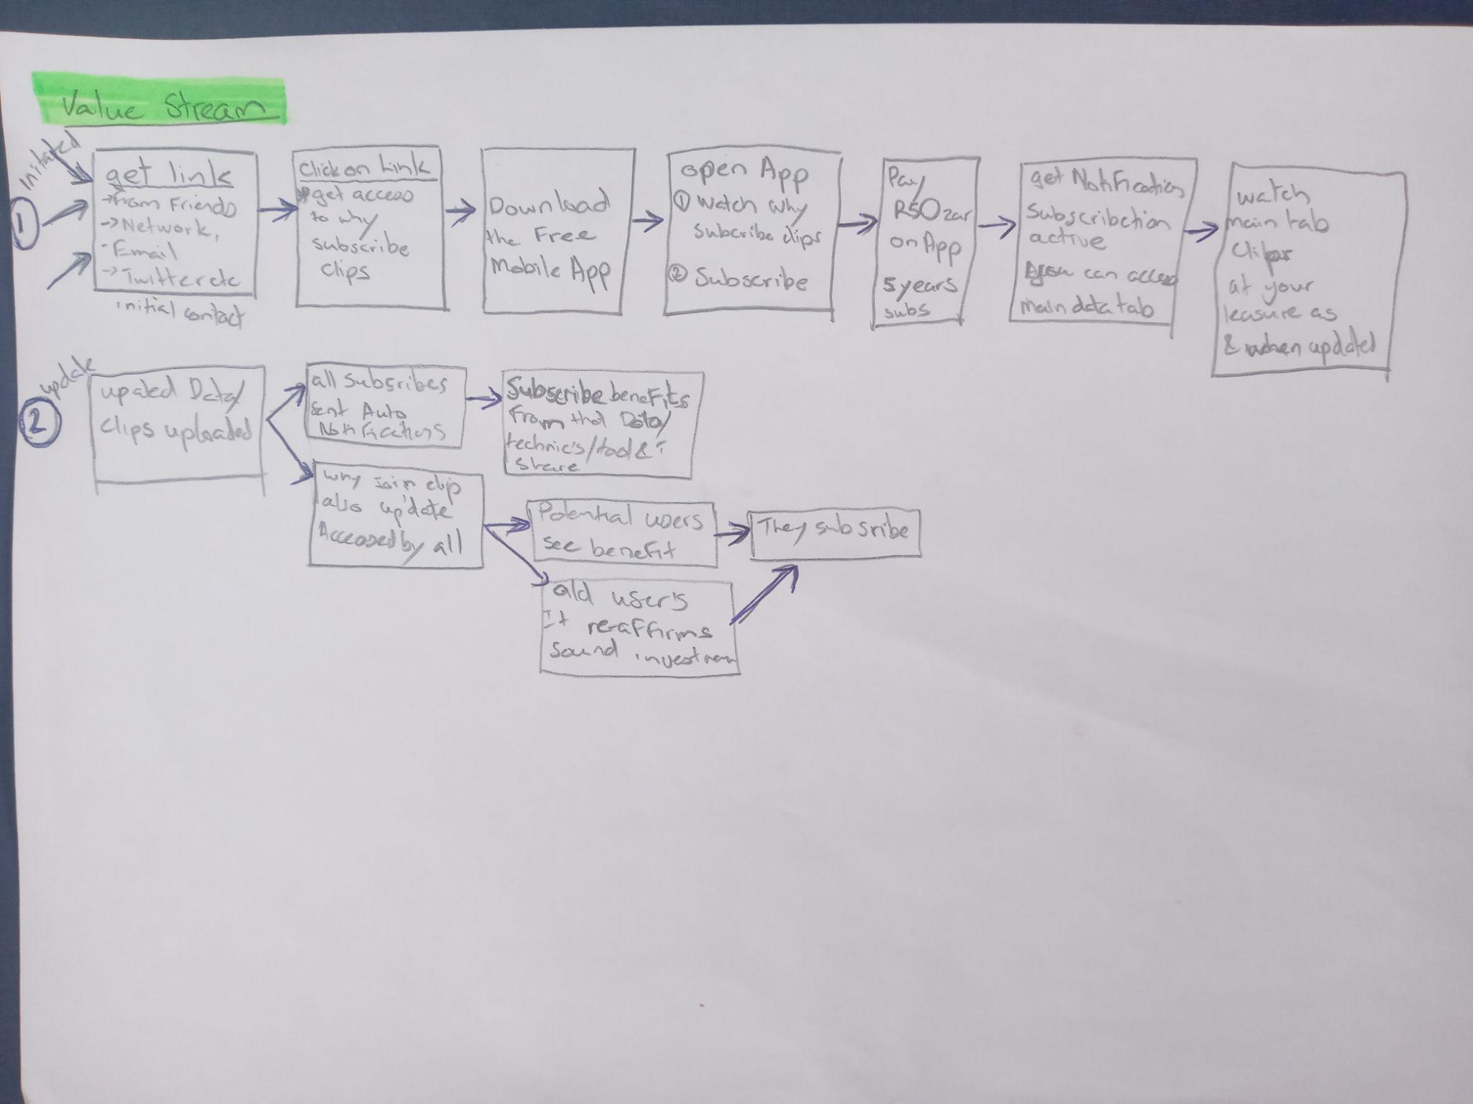

| **3. ASSUMPTIONS FOR ESTIMATION** | |
| --- | --- |
| **S No.** | **Items** |
| 1 | The project is for iPhone and Android phones and will support portrait mode orientation only. |
| 2 | The application will work in the English language only. |
| 3 | We have estimated this application based on details received from the client. Our time estimation will vary if some new screen will be added or there will be some amendments in app requirements. |
| 4 | In order to submit this application on app stores, we need proper details of this application from the client. We will also need Apple app store & Google Play Store account details from the client which would cost him $99 per year and $25 for lifetime respectively. |
| 5 | Any free or paid third party SDK required at the time of development will need to be provided by the client. |
| 6 | Please note that the app will not work when there will be no internet connection. |
| 7 | Please inform us in case, if we have forgotten to mention any essential functionality that must be included while project development. |
| 8 | Please inform us in case, if we have mentioned any unnecessary modules that must be excluded while project development. |
| 9 | In the queries section of this document we have mentioned some queries, this time and cost estimation may vary after getting replies on those queries. |
| 10 | Only admin posted videos/audio/documentation will be notified to the users. |
| 11 | No option to record video/audio/documentation only uploading from storage. |
| 12 | Referral friend to earn reward or some benefits. |

| **4. QUERIES FOR CLIENT (Answers may impact estimation time & cost)** | |
| --- | --- |
| **S No.** | **Items** |
|  |  |

| **5. TARGET PLATFORM** | | | | |
| --- | --- | --- | --- | --- |
| **Sno.** | **Platform** | **WBS/Deliverable** | **Sub Platform** | **Included** |
| 1. | Mobile | Mobile Apps | Android Phones Excluding Android Tablets &  iOS Phones  Excluding iPads | Yes |

| **6. PLATFORM COMPATIBILITY BASELINES** | | | |
| --- | --- | --- | --- |
| **Application** | **Operating System** | **Device / Make** | **Browser** |
| Android App | Android 6.x to 12.x | Asus Nexus 7(6.0), Moto G (5.1), Samsung S7 Edge (7.1.0), Nexus 5x (8.1.0) | N/A |
| iOS App | iOS 13.x to 15.x | iPhone 6, 6s, 7, 8 and iPhone Xs. and above. | N/A |

| **7. SCOPE OF WORK** |
| --- |

**7.1 Mobile Development:**

**Modules Description:**

| **S. No** | **Tasks** | **Sub Task** | **Remarks** |
| --- | --- | --- | --- |
| 1 | Splash  Screen | 1. 2-3 Second 2. Logo   Move to next screen |  |
| 2 | Welcome | In this screen user will get three options   1. Login 2. Registration 3. Skip login |  |
| 3 | Login | * 1. Email id   2. Password   3. Social login      1. Facebook      2. Google   4. New user? Register   5. Forgot password |  |
| 4 | Registration | * 1. Name   2. Email id   3. Password   4. Gender   5. Date of birth   6. Submit      1. Click move to OTP screen      2. OTP will be received on entered email   7. Already registered ? Login |  |
| 5 | OTP | * 1. 6 digit OTP code which was received on email   2. Resend OTP   3. Submit      1. Success:         1. Welcome to PPMO Ecosystem, @name. You are successfully verified.         2. Get Started button      2. Failed :         1. Enter OTP is not correct |  |
| 6 | Forgot Password | * 1. Enter registered email address   2. Enter OTP : received on registered email address   3. Resend OTP   4. Submit      1. Success : Email received with reset password   Failed : Enter OTP is not correctly entered |  |
| 7 | Bottom bar | 1. Home 2. Favourite 3. My uploads 4. My Profile |  |
| 8 | Home | 1. Videos uploaded by admin 2. Audio uploaded by admin 3. Documentation by admin 4. Filter :    1. Videos    2. Documents    3. Audios    4. All 5. Like post 6. Mark as favourite 7. Share video/audio/documentation 8. Unsubscribed users will not able to watch admin uploaded data they will get alert to buy a subscription to review 9. Subscribed user has full access to application and features 10. Notification/ bell icon |  |
| 9 | Favourite | 1. List of videos/ audio/ documents 2. Filter    1. Video    2. Audio    3. Documents    4. All 3. Remove from favorite 4. Share post |  |
| 10. | My uploads | 1. Free or non-subscribed users will able to upload upto 3 videos/audio/documentation 2. No option to delete uploaded data only can update version like v1/v2/so on 3. Subscribed user can upload n number of video/audio/documentation based on buyed plan 4. Share uploaded data 5. Description 6. Title 7. List of uploads |  |
| 11 | My Profile | 1. Edit profile 2. Subscription plans 3. Family tree 4. Refer to friend 5. Change password 6. Change language (Currently it will show only English) 7. Privacy policy 8. Terms and condition 9. Share app 10. Watch Ancestor uploaded data |  |
| 12 | Edit profile | **Personal Details**   1. Upload image 2. Edit name 3. Non editable : Email (so that we have one value as unique in system) 4. Edit mobile number (But need OTP verification again) 5. Gender 6. DOB   **Other Details**   1. Grand father    1. Name    2. Mobile    3. Email id 2. Father    1. Name    2. Mobile    3. Email id 3. Education details 4. Current status    1. Married    2. Divosed, etc 5. Work status   Fields will be compulsory in **Other Information** based on the condition/ requirement |  |
| 13 | Subscription plans | 1. Showing buyed plan 2. Other subscription available along with details |  |
| 14 | Family tree | 1. Full name 2. DOB 3. Status    1. Living/ Alive    2. Death 4. Relationship dropdown 5. Addition information |  |
| 15 | Notification | 1. Only admin posted video/audio/documentation will be notify to the user 2. No notification if user post something |  |
| 16 | Refer to friend | 1. Earn reward or get some benefits after referring a friend and get him/her registered 2. No earning of reward or benefits until user does not post something in application |  |
| 17 | Change password | 1. Old password 2. New password 3. Confirm password |  |
| 18 | Change language | 1. Currently it will show only English language option to select |  |
| 19 | Other | 1. Privacy policy 2. Terms and Conditions |  |
| 20 | Share app | It will share the link to non-app user and request message to join app |  |
| 21 | Watch Ancestor | 1. Watch Uploaded video 2. WatchUploaded audio 3. WatchUploaded documents 4. Filter 5. Share 6. Like |  |

**7.2 API & Admin Development:**

| **S. No** | **Tasks** | **Sub Task** | **Remarks** |
| --- | --- | --- | --- |
| 1 | Website | Currently, we are managing separate video listings. For example, Grandfathers can add their own videos. And child can add their own videos.  We need to manage relationships between them. If the grandfather will upload their videos,audios and documents then it will be accessible to their child. |  |
| 2 | API | We will create an API according to mobile app module. |  |
|  |  |  |  |
| **Design Estimation** | | | |
| 1 | App design | Following screens need to be designed based on Ios and Android norms..  List of screens:  Welcome Screen  Welcome  Login  Registration  Forgot Password  Home  Favourite  My uploads  My Profile  Edit profile  Subscription plans  Family tree  Notification  Refer to friend  Change password  Change language  Privacy policy  Terms and Conditions |  |
| Note:  *extra UI design according to change in the functionality will cost Extra hours per screen.  *Given estimation is according to the requirement given by client and discussion with developer if change in functionality may vary the time estimation according to that | | | |

| **8. RESOURCE** | | | | |
| --- | --- | --- | --- | --- |

| **Skills/ Technology** | **No. of Resources** | **Time Required (Hours)** | **Costs in USD** |
| --- | --- | --- | --- |
| iOS & Android Application with Cross Platform App Development using Flutter | 1 | 340 | Flutter app |
| Design | 1 | 86 | UI design + Logo |
| Web-Services (API’s) | 1 | 170 |  |
| Front Website | 1 | 40 |  |
| Development QA | 1 | 56 |  |
| Total |  | 692 |  |

| **8.1 PROJECT MILESTONES/SPRINTS** | | | | |
| --- | --- | --- | --- | --- |

| **Sprint Name** | **Features Details** | **Duration** | **Costs in USD $** |
| --- | --- | --- | --- |
| Sprint 1 | **UI Design :** Complete UI design  **App Development:** Initial setup and from point 1 to 6 i.e. Splash, Welcome, Login, Registration, OTP & Forgot Password Screens.  **Web Admin & APIs Development:** Initial setup of API’s and providing API for app development from point 1 to 6 i.e. Splash, Welcome, Login, Registration, OTP & Forgot Password Screens | 2.5 Weeks |  |
| Sprint 2 | **UI Design :** Any design updation or left in sprint 1  **App Development:** From point 7 to point 9 including bugs or lefted points if occurred in sprint 1 along with point 10 initial start i.e Bottom Bar, Home, Favourite  **Web Admin & APIs Development:** Providing API for app development from point 7 to 9 i.e Bottom Bar, Home, Favourite | 2 Weeks |  |
| Sprint 3 | **UI Design :** Any design updation or left in sprint 2  **App Development:** From point 10 to point 13 including bugs or lefted points if occurred in sprint 2 along with point 14 initial start i.e. My uploads, My profile, Edit Profile, Subscription plans  **Web Admin & APIs Development:** Providing API for app development from point 10 to 13 i.e. My uploads, My profile, Edit Profile, Subscription plans | 2.5 Weeks |  |
| Sprint 4 | **UI Design :** Any design updation or left in sprint 3  **App Development:** From point 14 to point 21 including bugs or lefted points if occurred in sprint 3 i.e Family tree, Notification, Refer to friend, Change Password, Change language, Other, Share App , Watch Accenture  **Web Admin & APIs Development:** Providing API for app development from point 14 to 21 i.e Family tree, Notification, Refer to friend, Change Password, Change language, Other, Share App , Watch Accenture | 2 Weeks |  |
| Sprint 5 | Testing and bug solving + Deploy and publish applications on respective app stores. | 1 Week |

For Admin UI, we will use a free available template.  
<https://adminlte.io/themes/v3/pages/examples/projects.html>

| **9. TECHNOLOGY STACK BASELINES** | |
| --- | --- |
| Development Technology | Flutter, Node JS |
| Programming Language | Dart, Java Script |
| Database | MySql |

| **10. KNOWN RISKS & ESCALATION MATRIX (excluding cis internal)** | | | |  |
| --- | --- | --- | --- | --- |
| **S.N.** | **Risk** | **Probability Of Occurrence  (1 - 5)** | **Risk Impact on project  (1 - 5)** |  |
| 1 | New OS version launch of iOS or Android | 2 | 1 | 2 |

| **11. ACCEPTANCE CRITERIA** |
| --- |

* Deliveries as per Baselines Above

| **12. OUT OF SCOPE** | |
| --- | --- |
| **S.No.** | **Items** |
| 1 | Android tablet & iPad support is not included in this estimation. |
| 2 | Android versions except 6.0 to 11.0 & iOS version except 13.X to 15.x |

| **13. PREREQUISITES** | |
| --- | --- |
| **S.No.** | **Items** |
| 1 | Apple & Google account developer account login details. |
| 2 | Hosting and server details. |
| 3 | Firebase account. |
| 4 | We will require SMTP details for sending email. |

| **14. STAGING/ ALPHA & BETA TESTING ENVIRONMENTS** |
| --- |

Environment (update based on the project requirement)

| **15. SPECIAL HARDWARE & SOFTWARE REQUIREMENT** |
| --- |

(Optional, vary based on the project requirement)

| **16. REPORTING TOOLS** |
| --- |

We will give you access of CIS PMS (Project Management System) to you and your inhouse team, you will be able to get updates from CIS team on daily basis, can post your inputs, feedbacks, documents etc. and/ or add your own tickets, for CIS Team member to work on.

| **17. PROJECT MONITORING (PROJECT BASIS ONLY)** |
| --- |

Project will be monitored and managed by CIS Project Manager(s) and before any deployment it will be checked by CIS QA Team focusing on delivering a working, successful Product.

We will give you the access of development server/ Alpha Testing Server of CIS (max 1 CPU, 1 GB RAM, 300 MB SSD Space), so that you can check the project and daily work done by CIS team members. More Alpha server resource may cost additional, please check with your accounts manager at CIS.

| **18. SERVICE AFTER DEPLOYMENT** |
| --- |

We will provide free bug fixing services for the work we have completed as per our Sales Agreement with you, excluding for:

* Issues in any pre-existing code, we did not work on, but may be impacted (Specially in case of maintenance projects).
* Any out of scope bug or change requests which are not covered in this document.

| **19. TERMS & POLICIES** |
| --- |

* We will give you services level agreement for the project on which we agreed on. Including all features and functionality with Payment Terms.
* We will provide you with a partial supervisor who ensures the quality & enterprises level standard solution. He/ She will monitor the project/work progress well.
* Team will have regular meetings with you on **SKYPE/JOIN ME/GOTOMEETING OR ON CALL** so that everyone should be on the same page.
* Team will send you a regular report through PMS so that you can check the work/task done each day.
* It is not a very deep drill down estimation, it may change during project execution, if so the client will be informed and discussed. Appropriate cost will be paid by the client.